22AIE204 Introduction to Networks Labsheet5

Socket Programming & Analyzing Packet Tracer Scenario
Name: Anuvind MP
Roll No.: AM.EN.U4AIE22010

Problem 1)
Write UDP client and server datagram to send messages among each other.
Server.py :
import socket

SERVER_IP = "127.0.0.1"
SERVER_PORT = 12345

server_socket = socket.socket(socket.AF_INET, socket.SOCK_DGRAM)

server_socket.bind((SERVER_IP, SERVER_PORT))
print(f"Server listening on {SERVER_IP}:{SERVER_PORT}")

while True:
data, client_address = server_socket.recvfrom(1024)
print(f"Received from client: {data.decode()}")

response = input("Enter your response: ")
server_socket.sendto(response.encode(), client_address)

client.py :
import socket

SERVER_IP = "127.0.0.1"
SERVER_PORT = 12345

client_socket = socket.socket(socket.AF_INET, socket.SOCK_DGRAM)

try:
while True:
message = input("Enter your message: ")
client_socket.sendto(message.encode(), (SERVER_IP, SERVER_PORT))

response, server_address = client_socket.recvfrom(1024)
print(f"Received from server: {response.decode()}")

if message.lower() == "exit":
break
finally:
client_socket.close()

Problem 2) Write TCP client and server datagram to send messages among each other.
Server.py :
import socket

SERVER_IP = "127.0.0.1"
SERVER_PORT = 12345

server_socket = socket.socket(socket.AF_INET, socket.SOCK_STREAM)

server_socket.bind((SERVER_IP, SERVER_PORT))

server_socket.listen(1)
print(f"Server listening on {SERVER_IP}:{SERVER_PORT}")

client_socket, client_address = server_socket.accept()
print(f"Connection established with {client_address}")

try:
while True:
data = client_socket.recv(1024)
if not data:
break
print(f"Received from client: {data.decode()}")

response = input("Enter your response: ")
client_socket.sendall(response.encode())
finally:
client_socket.close()
server_socket.close()
print("Connection closed")

client.py :
import socket

SERVER_IP = "127.0.0.1"
SERVER_PORT = 12345

client_socket = socket.socket(socket.AF_INET, socket.SOCK_STREAM)

client_socket.connect((SERVER_IP, SERVER_PORT))
print(f"Connected to server at {SERVER_IP}:{SERVER_PORT}")

try:
while True:
message = input("Enter your message: ")
client_socket.sendall(message.encode())

response = client_socket.recv(1024)
print(f"Received from server: {response.decode()}")

if message.lower() == "exit":
break
finally:
client_socket.close()
print("Connection closed")

Problem 3)
After login to netacad.com, download latest version of Packet Tracer. Now open the Labsheet5scenario.pkt file.
Answer the following questions:
- What is the subnet mask of CAD Lab subnet.
- The subnet mask of CAD subnet is 255.255.255.0
The subnet mask of amritavidya.edu subnet is 255.255.255.252
The subnet mask of amrita.edu subnet is 255.255.255.252
- What is the IP address of DHCP server and DNS server?
- The IP address of DHCP server is 192.168.0.2
The IP address of DNS server is 192.168.0.5
- Open amrita.edu from the browser of PC0, PC1 or PC2.
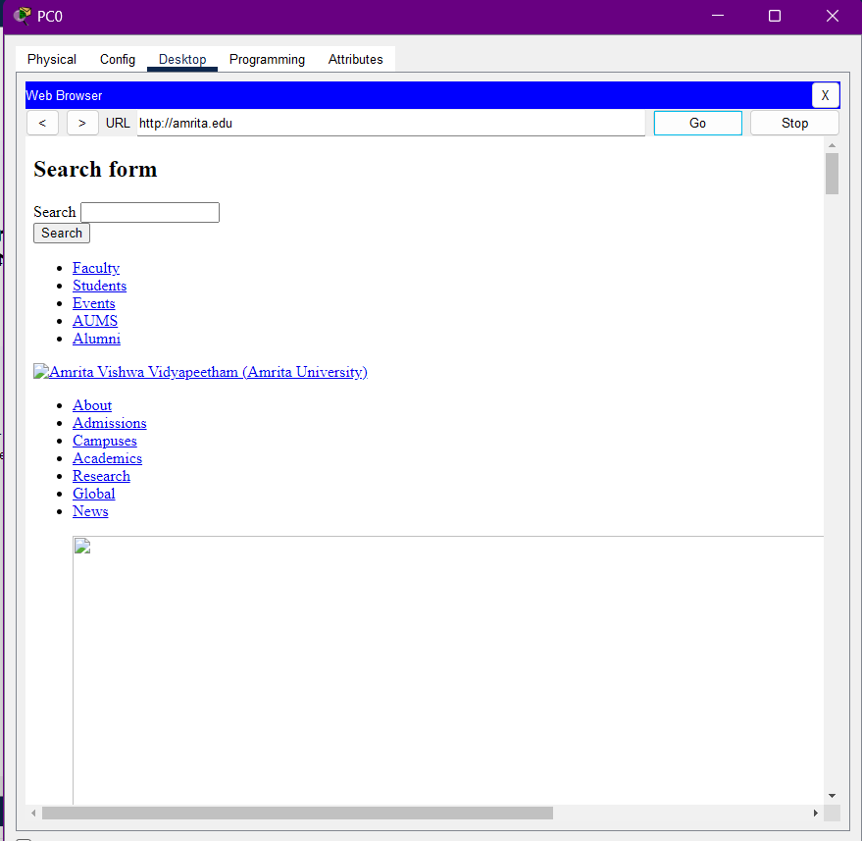
- How many subnets are there?
- There are 3 subnets.
The CAD subnet
The amritavidya.edu subnet
The amrita.edu subnet
- Does the DHCP and DNS server belongs to the same subnet/network of PC1 or PC2.
- No, the PC1 and PC2 belong to a different subnet called CAD subnet with subnet mask of 255.255.255.0. while the DHCP server and DNS server belongs to the subnet called amritavidya.edu subnet with subnet mask of 255.255.255.252.

